Министерство образования республики Беларусь
Учреждение образования
«БЕЛОРУССКИЙ ГОСУДАРСТВЕННЫЙ УНИВЕРСИТЕТ ИНФОРМАТИКИ И РАДИОЭЛЕКТРОНИКИ»

Факультет «ФИНО»
Специальность «ИиТП»

Контрольная работа
По теме «Асимметричные системы шифрования. Криптосистема RSA»

По предмету «Методы защиты информации»

Студент дистанционной формы обучения 4 курса
Группы № 493551
Авхимович Алексей Валерьевич
г. Борисов, ул. Чапаева, д. 29 кв.116
Тел. +375-44-7900085

Минск, 2018

Содержание
Введение 3
Блок-схема алгоритма 4
Результаты ввода данных и исполнения программы 6
Вывод 16

Введение
Контрольная работа № 2 подразумевает изучение и программную реализацию алгоритма стандарта цифровой подписи ГОСТ 3410.
Целью работы является создание и тестирование алгоритма цифровой подписи ГОСТ 3410 на языке высокого уровня.

Блок-схема алгоритма
Формирование цифровой подписи:
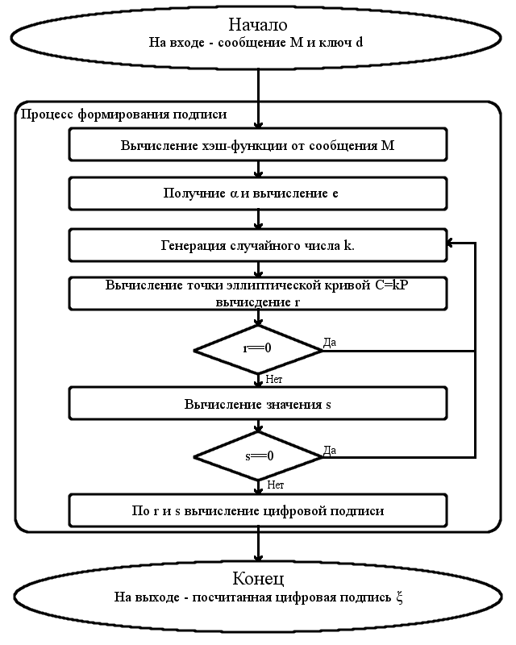

Проверка цифровой подписи:
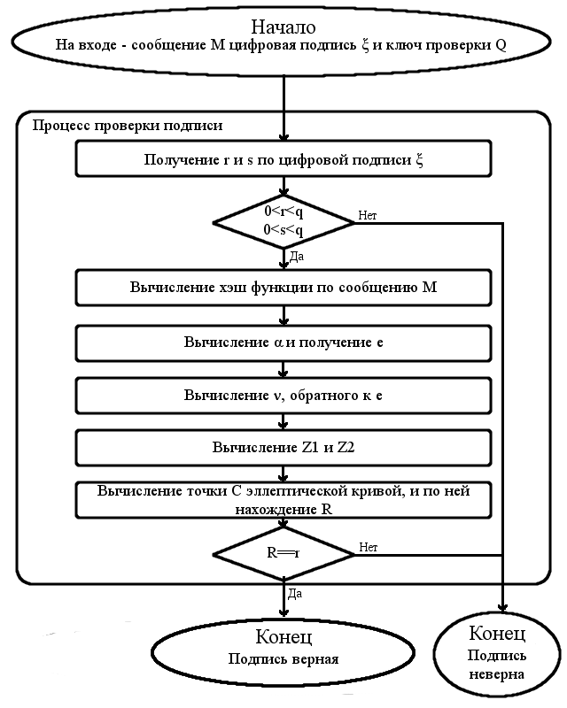

Результаты ввода данных и исполнения программы

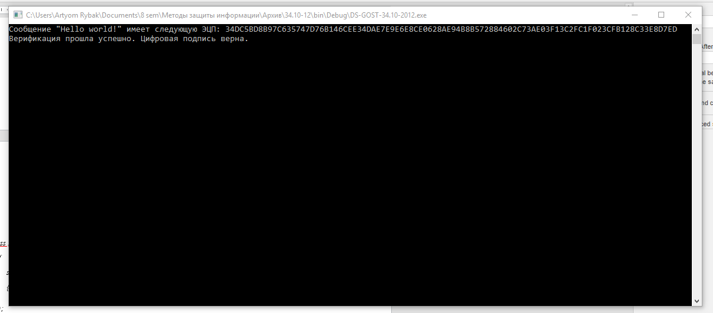

Програмный код
class Program
{
static void Main(string[] args)
{
BigInteger p = new BigInteger("6277101735386680763835789423207666416083908700390324961279", 10);
BigInteger a = new BigInteger("-3", 10);
BigInteger b = new BigInteger("64210519e59c80e70fa7e9ab72243049feb8deecc146b9b1", 16);
byte[] xG = fromHexStringToByte("03188da80eb03090f67cbf20eb43a18800f4ff0afd82ff1012");
BigInteger n = new BigInteger("ffffffffffffffffffffffff99def836146bc9b1b4d22831", 16);

CDS DS = new CDS(p, a, b, n, xG);
BigInteger d = DS.genPrivateKey(192);
CECPoint Q = DS.genPublicKey(d);
CStribog hash = new CStribog(256);
/*
byte[] H = hash.GetHash(Encoding.Default.GetBytes("Message"));
string sign = DS.genDS(H, d);

byte[] H2 = hash.GetHash(Encoding.Default.GetBytes("message"));
string sign2 = DS.genDS(H2, d);
*/

String path = "test.txt";
String message = readFile(path);
byte[] H = hash.GetHash(Encoding.Default.GetBytes(message));
string sign = DS.genDS(H, d);
Console.WriteLine("Сообщение \"{0}\" имеет следующую ЭЦП: {1}", message, sign);
path = "out.txt";
writeFile(path, sign);

path = "verify.txt";
String message2 = readFile(path);
byte[] H2 = hash.GetHash(Encoding.Default.GetBytes(message2));
path = "out.txt";
string signVer= readFile(path);
//string sign2 = DS.genDS(H2, d);

bool result = DS.verifDS(H2, signVer, Q);

if (result)
System.Console.WriteLine("Верификация прошла успешно. Цифровая подпись верна.");
else
System.Console.WriteLine("Верификация не прошла! Цифровая подпись не верна.");

System.Console.ReadLine();
}

private static byte[] fromHexStringToByte(string input)
{
byte[] data = new byte[input.Length / 2];
string HexByte = "";
for (int i = 0; i < data.Length; i++)
{
HexByte = input.Substring(i * 2, 2);
data[i] = Convert.ToByte(HexByte, 16);
}
return data;
}

private static string readFile(string path)
{
string text = System.IO.File.ReadAllText(path);
return (text);
}

private static void writeFile(string path, string text)
{
System.IO.File.WriteAllText(path, text);
}
}

class CStribog
{
//бинарная матрица A, используется для функции перемножения (L-преобразование).
private ulong[] A =
{
0x8e20faa72ba0b470, 0x47107ddd9b505a38, 0xad08b0e0c3282d1c, 0xd8045870ef14980e,
0x6c022c38f90a4c07, 0x3601161cf205268d, 0x1b8e0b0e798c13c8, 0x83478b07b2468764,
0xa011d380818e8f40, 0x5086e740ce47c920, 0x2843fd2067adea10, 0x14aff010bdd87508,
0x0ad97808d06cb404, 0x05e23c0468365a02, 0x8c711e02341b2d01, 0x46b60f011a83988e,
0x90dab52a387ae76f, 0x486dd4151c3dfdb9, 0x24b86a840e90f0d2, 0x125c354207487869,
0x092e94218d243cba, 0x8a174a9ec8121e5d, 0x4585254f64090fa0, 0xaccc9ca9328a8950,
0x9d4df05d5f661451, 0xc0a878a0a1330aa6, 0x60543c50de970553, 0x302a1e286fc58ca7,
0x18150f14b9ec46dd, 0x0c84890ad27623e0, 0x0642ca05693b9f70, 0x0321658cba93c138,
0x86275df09ce8aaa8, 0x439da0784e745554, 0xafc0503c273aa42a, 0xd960281e9d1d5215,
0xe230140fc0802984, 0x71180a8960409a42, 0xb60c05ca30204d21, 0x5b068c651810a89e,
0x456c34887a3805b9, 0xac361a443d1c8cd2, 0x561b0d22900e4669, 0x2b838811480723ba,
0x9bcf4486248d9f5d, 0xc3e9224312c8c1a0, 0xeffa11af0964ee50, 0xf97d86d98a327728,
0xe4fa2054a80b329c, 0x727d102a548b194e, 0x39b008152acb8227, 0x9258048415eb419d,
0x492c024284fbaec0, 0xaa16012142f35760, 0x550b8e9e21f7a530, 0xa48b474f9ef5dc18,
0x70a6a56e2440598e, 0x3853dc371220a247, 0x1ca76e95091051ad, 0x0edd37c48a08a6d8,
0x07e095624504536c, 0x8d70c431ac02a736, 0xc83862965601dd1b, 0x641c314b2b8ee083
};

//таблица подстановок, используется для функции подстановки (S-преобразование).
private byte[] Sbox=
{
0xFC, 0xEE, 0xDD, 0x11, 0xCF, 0x6E, 0x31, 0x16, 0xFB, 0xC4, 0xFA, 0xDA, 0x23, 0xC5, 0x04, 0x4D,
0xE9, 0x77, 0xF0, 0xDB, 0x93, 0x2E, 0x99, 0xBA, 0x17, 0x36, 0xF1, 0xBB, 0x14, 0xCD, 0x5F, 0xC1,
0xF9, 0x18, 0x65, 0x5A, 0xE2, 0x5C, 0xEF, 0x21, 0x81, 0x1C, 0x3C, 0x42, 0x8B, 0x01, 0x8E, 0x4F,
0x05, 0x84, 0x02, 0xAE, 0xE3, 0x6A, 0x8F, 0xA0, 0x06, 0x0B, 0xED, 0x98, 0x7F, 0xD4, 0xD3, 0x1F,
0xEB, 0x34, 0x2C, 0x51, 0xEA, 0xC8, 0x48, 0xAB, 0xF2, 0x2A, 0x68, 0xA2, 0xFD, 0x3A, 0xCE, 0xCC,
0xB5, 0x70, 0x0E, 0x56, 0x08, 0x0C, 0x76, 0x12, 0xBF, 0x72, 0x13, 0x47, 0x9C, 0xB7, 0x5D, 0x87,
0x15, 0xA1, 0x96, 0x29, 0x10, 0x7B, 0x9A, 0xC7, 0xF3, 0x91, 0x78, 0x6F, 0x9D, 0x9E, 0xB2, 0xB1,
0x32, 0x75, 0x19, 0x3D, 0xFF, 0x35, 0x8A, 0x7E, 0x6D, 0x54, 0xC6, 0x80, 0xC3, 0xBD, 0x0D, 0x57,
0xDF, 0xF5, 0x24, 0xA9, 0x3E, 0xA8, 0x43, 0xC9, 0xD7, 0x79, 0xD6, 0xF6, 0x7C, 0x22, 0xB9, 0x03,
0xE0, 0x0F, 0xEC, 0xDE, 0x7A, 0x94, 0xB0, 0xBC, 0xDC, 0xE8, 0x28, 0x50, 0x4E, 0x33, 0x0A, 0x4A,
0xA7, 0x97, 0x60, 0x73, 0x1E, 0x00, 0x62, 0x44, 0x1A, 0xB8, 0x38, 0x82, 0x64, 0x9F, 0x26, 0x41,
0xAD, 0x45, 0x46, 0x92, 0x27, 0x5E, 0x55, 0x2F, 0x8C, 0xA3, 0xA5, 0x7D, 0x69, 0xD5, 0x95, 0x3B,
0x07, 0x58, 0xB3, 0x40, 0x86, 0xAC, 0x1D, 0xF7, 0x30, 0x37, 0x6B, 0xE4, 0x88, 0xD9, 0xE7, 0x89,
0xE1, 0x1B, 0x83, 0x49, 0x4C, 0x3F, 0xF8, 0xFE, 0x8D, 0x53, 0xAA, 0x90, 0xCA, 0xD8, 0x85, 0x61,
0x20, 0x71, 0x67, 0xA4, 0x2D, 0x2B, 0x09, 0x5B, 0xCB, 0x9B, 0x25, 0xD0, 0xBE, 0xE5, 0x6C, 0x52,
0x59, 0xA6, 0x74, 0xD2, 0xE6, 0xF4, 0xB4, 0xC0, 0xD1, 0x66, 0xAF, 0xC2, 0x39, 0x4B, 0x63, 0xB6
};

//таблица перестановок, используется для функции перестановки (P-преобразование).
private byte[] Tau=
{
0, 8, 16, 24, 32, 40, 48, 56,
1, 9, 17, 25, 33, 41, 49, 57,
2, 10, 18, 26, 34, 42, 50, 58,
3, 11, 19, 27, 35, 43, 51, 59,
4, 12, 20, 28, 36, 44, 52, 60,
5, 13, 21, 29, 37, 45, 53, 61,
6, 14, 22, 30, 38, 46, 54, 62,
7, 15, 23, 31, 39, 47, 55, 63
};

//константный набор значений, для формирования временного ключа.
private byte[][] C =
{
new byte[64]
{
0xb1,0x08,0x5b,0xda,0x1e,0xca,0xda,0xe9,0xeb,0xcb,0x2f,0x81,0xc0,0x65,0x7c,0x1f,
0x2f,0x6a,0x76,0x43,0x2e,0x45,0xd0,0x16,0x71,0x4e,0xb8,0x8d,0x75,0x85,0xc4,0xfc,
0x4b,0x7c,0xe0,0x91,0x92,0x67,0x69,0x01,0xa2,0x42,0x2a,0x08,0xa4,0x60,0xd3,0x15,
0x05,0x76,0x74,0x36,0xcc,0x74,0x4d,0x23,0xdd,0x80,0x65,0x59,0xf2,0xa6,0x45,0x07
},
new byte[64]
{
0x6f,0xa3,0xb5,0x8a,0xa9,0x9d,0x2f,0x1a,0x4f,0xe3,0x9d,0x46,0x0f,0x70,0xb5,0xd7,
0xf3,0xfe,0xea,0x72,0x0a,0x23,0x2b,0x98,0x61,0xd5,0x5e,0x0f,0x16,0xb5,0x01,0x31,
0x9a,0xb5,0x17,0x6b,0x12,0xd6,0x99,0x58,0x5c,0xb5,0x61,0xc2,0xdb,0x0a,0xa7,0xca,
0x55,0xdd,0xa2,0x1b,0xd7,0xcb,0xcd,0x56,0xe6,0x79,0x04,0x70,0x21,0xb1,0x9b,0xb7
},
new byte[64]
{
0xf5,0x74,0xdc,0xac,0x2b,0xce,0x2f,0xc7,0x0a,0x39,0xfc,0x28,0x6a,0x3d,0x84,0x35,
0x06,0xf1,0x5e,0x5f,0x52,0x9c,0x1f,0x8b,0xf2,0xea,0x75,0x14,0xb1,0x29,0x7b,0x7b,
0xd3,0xe2,0x0f,0xe4,0x90,0x35,0x9e,0xb1,0xc1,0xc9,0x3a,0x37,0x60,0x62,0xdb,0x09,
0xc2,0xb6,0xf4,0x43,0x86,0x7a,0xdb,0x31,0x99,0x1e,0x96,0xf5,0x0a,0xba,0x0a,0xb2
},
new byte[64]
{
0xef,0x1f,0xdf,0xb3,0xe8,0x15,0x66,0xd2,0xf9,0x48,0xe1,0xa0,0x5d,0x71,0xe4,0xdd,
0x48,0x8e,0x85,0x7e,0x33,0x5c,0x3c,0x7d,0x9d,0x72,0x1c,0xad,0x68,0x5e,0x35,0x3f,
0xa9,0xd7,0x2c,0x82,0xed,0x03,0xd6,0x75,0xd8,0xb7,0x13,0x33,0x93,0x52,0x03,0xbe,
0x34,0x53,0xea,0xa1,0x93,0xe8,0x37,0xf1,0x22,0x0c,0xbe,0xbc,0x84,0xe3,0xd1,0x2e
},
new byte[64]
{
0x4b,0xea,0x6b,0xac,0xad,0x47,0x47,0x99,0x9a,0x3f,0x41,0x0c,0x6c,0xa9,0x23,0x63,
0x7f,0x15,0x1c,0x1f,0x16,0x86,0x10,0x4a,0x35,0x9e,0x35,0xd7,0x80,0x0f,0xff,0xbd,
0xbf,0xcd,0x17,0x47,0x25,0x3a,0xf5,0xa3,0xdf,0xff,0x00,0xb7,0x23,0x27,0x1a,0x16,
0x7a,0x56,0xa2,0x7e,0xa9,0xea,0x63,0xf5,0x60,0x17,0x58,0xfd,0x7c,0x6c,0xfe,0x57
},
new byte[64]
{
0xae,0x4f,0xae,0xae,0x1d,0x3a,0xd3,0xd9,0x6f,0xa4,0xc3,0x3b,0x7a,0x30,0x39,0xc0,
0x2d,0x66,0xc4,0xf9,0x51,0x42,0xa4,0x6c,0x18,0x7f,0x9a,0xb4,0x9a,0xf0,0x8e,0xc6,
0xcf,0xfa,0xa6,0xb7,0x1c,0x9a,0xb7,0xb4,0x0a,0xf2,0x1f,0x66,0xc2,0xbe,0xc6,0xb6,
0xbf,0x71,0xc5,0x72,0x36,0x90,0x4f,0x35,0xfa,0x68,0x40,0x7a,0x46,0x64,0x7d,0x6e
},
new byte[64]
{
0xf4,0xc7,0x0e,0x16,0xee,0xaa,0xc5,0xec,0x51,0xac,0x86,0xfe,0xbf,0x24,0x09,0x54,
0x39,0x9e,0xc6,0xc7,0xe6,0xbf,0x87,0xc9,0xd3,0x47,0x3e,0x33,0x19,0x7a,0x93,0xc9,
0x09,0x92,0xab,0xc5,0x2d,0x82,0x2c,0x37,0x06,0x47,0x69,0x83,0x28,0x4a,0x05,0x04,
0x35,0x17,0x45,0x4c,0xa2,0x3c,0x4a,0xf3,0x88,0x86,0x56,0x4d,0x3a,0x14,0xd4,0x93
},
new byte[64]
{
0x9b,0x1f,0x5b,0x42,0x4d,0x93,0xc9,0xa7,0x03,0xe7,0xaa,0x02,0x0c,0x6e,0x41,0x41,
0x4e,0xb7,0xf8,0x71,0x9c,0x36,0xde,0x1e,0x89,0xb4,0x44,0x3b,0x4d,0xdb,0xc4,0x9a,
0xf4,0x89,0x2b,0xcb,0x92,0x9b,0x06,0x90,0x69,0xd1,0x8d,0x2b,0xd1,0xa5,0xc4,0x2f,
0x36,0xac,0xc2,0x35,0x59,0x51,0xa8,0xd9,0xa4,0x7f,0x0d,0xd4,0xbf,0x02,0xe7,0x1e
},
new byte[64]
{
0x37,0x8f,0x5a,0x54,0x16,0x31,0x22,0x9b,0x94,0x4c,0x9a,0xd8,0xec,0x16,0x5f,0xde,
0x3a,0x7d,0x3a,0x1b,0x25,0x89,0x42,0x24,0x3c,0xd9,0x55,0xb7,0xe0,0x0d,0x09,0x84,
0x80,0x0a,0x44,0x0b,0xdb,0xb2,0xce,0xb1,0x7b,0x2b,0x8a,0x9a,0xa6,0x07,0x9c,0x54,
0x0e,0x38,0xdc,0x92,0xcb,0x1f,0x2a,0x60,0x72,0x61,0x44,0x51,0x83,0x23,0x5a,0xdb
},
new byte[64]
{
0xab,0xbe,0xde,0xa6,0x80,0x05,0x6f,0x52,0x38,0x2a,0xe5,0x48,0xb2,0xe4,0xf3,0xf3,
0x89,0x41,0xe7,0x1c,0xff,0x8a,0x78,0xdb,0x1f,0xff,0xe1,0x8a,0x1b,0x33,0x61,0x03,
0x9f,0xe7,0x67,0x02,0xaf,0x69,0x33,0x4b,0x7a,0x1e,0x6c,0x30,0x3b,0x76,0x52,0xf4,
0x36,0x98,0xfa,0xd1,0x15,0x3b,0xb6,0xc3,0x74,0xb4,0xc7,0xfb,0x98,0x45,0x9c,0xed
},
new byte[64]
{
0x7b,0xcd,0x9e,0xd0,0xef,0xc8,0x89,0xfb,0x30,0x02,0xc6,0xcd,0x63,0x5a,0xfe,0x94,
0xd8,0xfa,0x6b,0xbb,0xeb,0xab,0x07,0x61,0x20,0x01,0x80,0x21,0x14,0x84,0x66,0x79,
0x8a,0x1d,0x71,0xef,0xea,0x48,0xb9,0xca,0xef,0xba,0xcd,0x1d,0x7d,0x47,0x6e,0x98,
0xde,0xa2,0x59,0x4a,0xc0,0x6f,0xd8,0x5d,0x6b,0xca,0xa4,0xcd,0x81,0xf3,0x2d,0x1b
},
new byte[64]
{
0x37,0x8e,0xe7,0x67,0xf1,0x16,0x31,0xba,0xd2,0x13,0x80,0xb0,0x04,0x49,0xb1,0x7a,
0xcd,0xa4,0x3c,0x32,0xbc,0xdf,0x1d,0x77,0xf8,0x20,0x12,0xd4,0x30,0x21,0x9f,0x9b,
0x5d,0x80,0xef,0x9d,0x18,0x91,0xcc,0x86,0xe7,0x1d,0xa4,0xaa,0x88,0xe1,0x28,0x52,
0xfa,0xf4,0x17,0xd5,0xd9,0xb2,0x1b,0x99,0x48,0xbc,0x92,0x4a,0xf1,0x1b,0xd7,0x20
}
};

private byte[] iv =new byte[64];

private byte[] N =new byte[64];

private byte[] Sigma = new byte[64];

public int outLen = 0;

public CStribog(int outputLenght)
{
if (outputLenght == 512)
{
for (int i = 0; i < 64; i++)
{
N[i] = 0x00;
Sigma[i] = 0x00;
iv[i] = 0x00;
}
outLen = 512;
}
else if (outputLenght == 256)
{
for (int i = 0; i < 64; i++)
{
N[i] = 0x00;
Sigma[i] = 0x00;
iv[i] = 0x01;
}
outLen = 256;
}
}

private byte[] AddModulo512(byte[] a, byte[] b)
{
byte[] temp = new byte[64];
int i = 0, t = 0;
byte[] tempA = new byte[64];
byte[] tempB = new byte[64];
Array.Copy(a, 0, tempA, 64 - a.Length, a.Length);
Array.Copy(b, 0, tempB, 64 - b.Length, b.Length);
for (i = 63; i >= 0; i--)
{
t = tempA[i] + tempB[i] + (t >> 8);
temp[i] = (byte)(t & 0xFF);
}
return temp;
}

private byte[] AddXor512(byte[] a, byte[] b)
{
byte[] c = new byte[64];
for (int i = 0; i < 64; i++)
c[i] = (byte)(a[i] ^ b[i]);
return c;
}

private byte[] S(byte[] state)
{
byte[] result = new byte[64];
for (int i = 0; i < 64; i++)
result[i] = Sbox[state[i]];
return result;
}

private byte[] P(byte[] state)
{
byte[] result = new byte[64];
for (int i = 0; i < 64; i++)
{
result[i] = state[Tau[i]];
}
return result;
}

private byte[] L(byte[] state)
{
byte[] result = new byte[64];
for (int i = 0; i < 8; i++)
{
ulong t = 0;
byte[] tempArray = new byte[8];
Array.Copy(state, i * 8, tempArray, 0, 8);
tempArray = tempArray.Reverse().ToArray();
System.Collections.BitArray tempBits1 = new System.Collections.BitArray(tempArray);
bool[] tempBits=new bool[64];
tempBits1.CopyTo(tempBits, 0);
tempBits=tempBits.Reverse().ToArray();
for (int j = 0; j < 64; j++)
{
if (tempBits[j] != false)
t = t ^ A[j];
}
byte[] ResPart = BitConverter.GetBytes(t).Reverse().ToArray();
Array.Copy(ResPart, 0, result, i * 8, 8);
}
return result;
}

private byte[] KeySchedule(byte[] K, int i)
{
K=AddXor512(K, C[i]);
K = S(K);
K = P(K);
K = L(K);
return K;
}

private byte[] E(byte[] K, byte[] m)
{
byte[] state = AddXor512(K, m);
for (int i = 0; i < 12; i++)
{
state=S(state);
state = P(state);
state = L(state);
K=KeySchedule(K, i);
state = AddXor512(state, K);
}
return state;
}

private byte[] G_n(byte[] N, byte[] h, byte[] m)
{
byte[] K = AddXor512(h, N);
K=S(K);
K=P(K);
K=L(K);
byte[] t= E(K, m);
t=AddXor512(t, h);
byte[] newh = AddXor512(t, m);
return newh;
}

public byte[] GetHash(byte[] message)
{
byte[] paddedMes=new byte[64];
int len = message.Length * 8;
byte[] h = new byte[64];
Array.Copy(iv, h, 64);
byte[] N_0 =
{
0x00,0x00,0x00,0x00,0x00,0x00,0x00,0x00,0x00,0x00,0x00,0x00,0x00,0x00,0x00,0x00,
0x00,0x00,0x00,0x00,0x00,0x00,0x00,0x00,0x00,0x00,0x00,0x00,0x00,0x00,0x00,0x00,
0x00,0x00,0x00,0x00,0x00,0x00,0x00,0x00,0x00,0x00,0x00,0x00,0x00,0x00,0x00,0x00,
0x00,0x00,0x00,0x00,0x00,0x00,0x00,0x00,0x00,0x00,0x00,0x00,0x00,0x00,0x00,0x00
};
if (outLen == 512)
{
for (int i = 0; i < 64; i++)
{
N[i] = 0x00;
Sigma[i] = 0x00;
iv[i] = 0x00;
}
}
else if (outLen == 256)
{
for (int i = 0; i < 64; i++)
{
N[i] = 0x00;
Sigma[i] = 0x00;
iv[i] = 0x01;
}
}
byte[] N_512 = BitConverter.GetBytes(512);
int inc = 0;
while (len >= 512)
{
inc++;
byte[] tempMes = new byte[64];
Array.Copy(message, message.Length - inc*64, tempMes, 0, 64);
h=G_n(N, h, tempMes);
N = AddModulo512(N, N_512.Reverse().ToArray());
Sigma=AddModulo512(Sigma, tempMes);
len -= 512;
}
byte[] message1 = new byte[message.Length - inc * 64];
Array.Copy(message, 0, message1, 0, message.Length - inc * 64);
if (message1.Length < 64)
{
for (int i = 0; i < (64 - message1.Length - 1); i++)
{
paddedMes[i] = 0;
}
paddedMes[64 - message1.Length - 1] = 0x01;
Array.Copy(message1, 0, paddedMes, 64 - message1.Length, message1.Length);
}
h=G_n(N, h, paddedMes);
byte[] MesLen = BitConverter.GetBytes(message1.Length * 8);
N = AddModulo512(N, MesLen.Reverse().ToArray());
Sigma = AddModulo512(Sigma, paddedMes);
h = G_n(N_0, h, N);
h = G_n(N_0, h, Sigma);
if (outLen == 512)
return h;
else
{
byte[] h256 = new byte[32];
Array.Copy(h, 0, h256, 0, 32);
return h256;
}
}
}

class CECPoint
{
public BigInteger a;
public BigInteger b;
public BigInteger x;
public BigInteger y;
public BigInteger fieldChar;

public CECPoint()
{
a = new BigInteger();
b = new BigInteger();
x = new BigInteger();
y = new BigInteger();
fieldChar = new BigInteger();
}

public CECPoint(CECPoint p)
{
a = p.a;
b = p.b;
x = p.x;
y = p.y;
fieldChar = p.fieldChar;
}

//сложение пары точек.
public static CECPoint operator+(CECPoint p1, CECPoint p2)
{
CECPoint res = new CECPoint();
res.a = p1.a;
res.b = p1.b;
res.fieldChar = p1.fieldChar;

BigInteger dx = p2.x - p1.x;
BigInteger dy = p2.y - p1.y;

if (dx < 0)
dx += p1.fieldChar;
if (dy < 0)
dy += p1.fieldChar;

BigInteger t = (dy * dx.modInverse(p1.fieldChar)) % p1.fieldChar;

if (t < 0)
t += p1.fieldChar;

res.x = (t * t - p1.x - p2.x) % p1.fieldChar;
res.y = (t * (p1.x - res.x) - p1.y) % p1.fieldChar;

if (res.x < 0)
res.x += p1.fieldChar;
if (res.y < 0)
res.y += p1.fieldChar;

return (res);
}

//удвоение точки.
public static CECPoint doubling(CECPoint p)
{
CECPoint res = new CECPoint();

res.a = p.a;
res.b = p.b;
res.fieldChar = p.fieldChar;

BigInteger dx = 2 * p.y;
BigInteger dy = 3 * p.x * p.x + p.a;

if (dx < 0)
dx += p.fieldChar;
if (dy < 0)
dy += p.fieldChar;

BigInteger t = (dy * dx.modInverse(p.fieldChar)) % p.fieldChar;
res.x = (t*t - p.x - p.x) % p.fieldChar;
res.y = (t * (p.x - res.x) - p.y) % p.fieldChar;

if (res.x < 0)
res.x += p.fieldChar;
if (res.y < 0)
res.y += p.fieldChar;

return (res);
}

//умножение точки на число.
public static CECPoint multiply(CECPoint p, BigInteger c)
{
CECPoint res = p;
c = c - 1;
while(c!=0)
{
if ((c%2)!=0)
{
if ((res.x == p.x) || (res.y == p.y))
res = doubling(res);
else
res = res + p;
c=c-1;
}

c = c / 2;
p = doubling(p);
}

return (res);
}
}

class CDS
{
private BigInteger a = new BigInteger();
private BigInteger b = new BigInteger();
private BigInteger n = new BigInteger();
private BigInteger p = new BigInteger();
private byte[] xG;
private CECPoint G = new CECPoint();

public CDS(BigInteger p, BigInteger a, BigInteger b, BigInteger n, byte[] xG)
{
this.a = a;
this.b = b;
this.n = n;
this.p = p;
this.xG = xG;
}

//генерация секретного ключа заданной длины.
public BigInteger genPrivateKey(int BitSize)
{
BigInteger d = new BigInteger();
do
{
d.genRandomBits(BitSize, new Random());
} while ((d < 0) || (d > n));
return d;
}

//генерация публичного ключа (с помощью секретного).
public CECPoint genPublicKey(BigInteger d)
{
CECPoint G=gDecompression();
CECPoint Q = CECPoint.multiply(G, d);
return Q;
}

//восстановление координат Y из координаты X и бита четности Y.
private CECPoint gDecompression()
{
byte y = xG[0];
byte[] x=new byte[xG.Length-1];
Array.Copy(xG, 1, x, 0, xG.Length - 1);
BigInteger Xcord = new BigInteger(x);
BigInteger temp = (Xcord * Xcord * Xcord + a * Xcord + b) % p;
BigInteger beta = modSqrt(temp, p);
BigInteger Ycord = new BigInteger();
if ((beta % 2) == (y % 2))
Ycord = beta;
else
Ycord = p - beta;
CECPoint G = new CECPoint();
G.a = a;
G.b = b;
G.fieldChar = p;
G.x = Xcord;
G.y = Ycord;
this.G = G;
return G;
}

//вычисление квадратоного корня по модулю простого числа q.
public BigInteger modSqrt(BigInteger a, BigInteger q)
{
BigInteger b = new BigInteger();
do
{
b.genRandomBits(255, new Random());
}
while (legendre(b, q) == 1);

BigInteger s = 0;
BigInteger t = q - 1;
while ((t & 1) != 1)
{
s++;
t = t >> 1;
}

BigInteger InvA = a.modInverse(q);
BigInteger c = b.modPow(t, q);
BigInteger r = a.modPow(((t + 1) / 2), q);
BigInteger d = new BigInteger();
for (int i = 1; i < s; i++)
{
BigInteger temp = 2;
temp = temp.modPow((s - i - 1), q);
d = (r.modPow(2, q) * InvA).modPow(temp, q);
if (d == (q - 1))
r = (r * c) % q;
c = c.modPow(2, q);
}
return r;
}

//вычисление символа Лежандра.
public BigInteger legendre(BigInteger a, BigInteger q)
{
return a.modPow((q - 1) / 2, q);
}

//формирование цифровой подписи.
public string genDS(byte[] h, BigInteger d)
{
BigInteger a = new BigInteger(h);
BigInteger e = a % n;
if (e == 0)
e = 1;
BigInteger k = new BigInteger();
CECPoint C=new CECPoint();
BigInteger r=new BigInteger();
BigInteger s = new BigInteger();
do
{
do
{
k.genRandomBits(n.bitCount(), new Random());
}
while ((k < 0) || (k > n));

C = CECPoint.multiply(G, k);
r = C.x % n;
s = ((r * d) + (k * e)) % n;
}
while ((r == 0)||(s==0));

string Rvector = padding(r.ToHexString(), n.bitCount() / 4);
string Svector = padding(s.ToHexString(), n.bitCount() / 4);
return Rvector + Svector;
}

//проверка цифровой подписи.
public bool verifDS(byte[] H, string sign, CECPoint Q)
{
string Rvector = sign.Substring(0, n.bitCount() / 4);
string Svector = sign.Substring(n.bitCount() / 4, n.bitCount() / 4);
BigInteger r = new BigInteger(Rvector, 16);
BigInteger s = new BigInteger(Svector, 16);

if ((r < 1) || (r > (n - 1)) || (s < 1) || (s > (n - 1)))
return (false);

BigInteger a = new BigInteger(H);
BigInteger e = a % n;
if (e == 0)
e = 1;

BigInteger v = e.modInverse(n);
BigInteger z1 = (s * v) % n;
BigInteger z2 = n + ((-(r * v)) % n);
this.G = gDecompression();
CECPoint A = CECPoint.multiply(G, z1);
CECPoint B = CECPoint.multiply(Q, z2);
CECPoint C = A + B;
BigInteger R = C.x % n;
if (R == r)
return (true);
else
return (false);
}

//дополнить подпись нулями слева до длины n,
// где n - длина модуля в битах.
private string padding(string input, int size)
{
if (input.Length < size)
{
do
{
input = "0" + input;
}
while (input.Length < size);
}
return (input);
}
}

Вывод

ГОСТ Р 34.10-2012 основан на эллиптических кривых. Стойкость этого алгоритма основывается на сложности вычисления дискретного логарифма в группе точек эллиптической кривой, а также на стойкости хэш-функции. Можно утверждать, что вероятность взлома хэш-функции по ГОСТ 34.11 низкая, поэтому его можно использовать для следующих задач:
- Использование пары ключей (открытый, закрытый) для установления ключа сессии.
- Использование в сертификатах открытых ключей.
- Использование для защиты соединений в TLS (SSL, HTTPS, WEB).
- Защита целостности Интернет адресов и имён (DNSSEC).

